Bug Report:
1. Bug: PDF gets uploaded but rest of the agent is not able to access the data extracted from the pdf or it could be extraction of the data from PDF is not working or it could be pdf is not getting loaded.
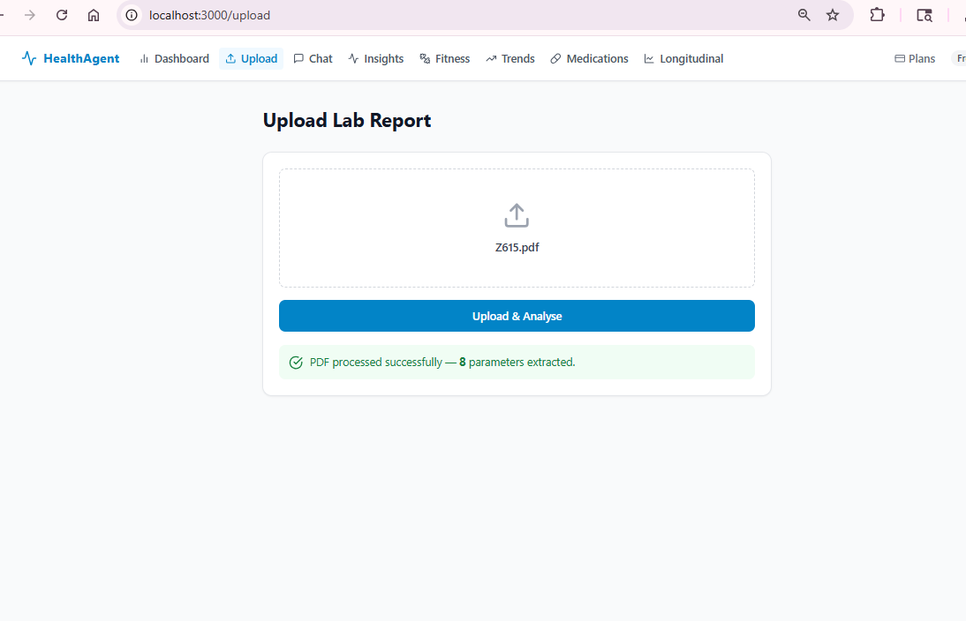
Once uplodad as show above, I get the below errors:
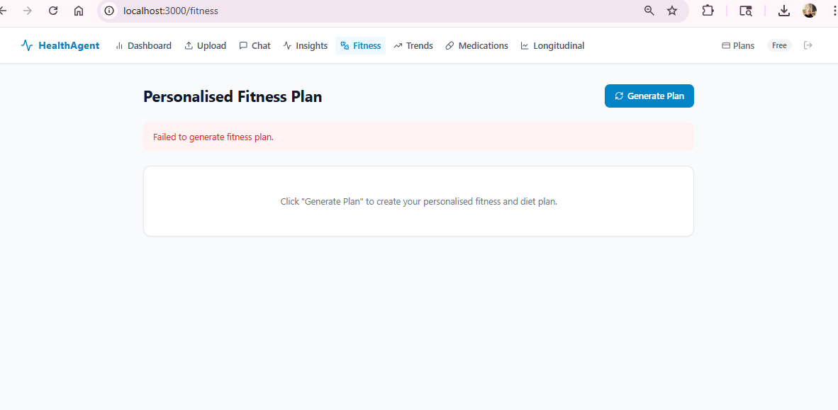
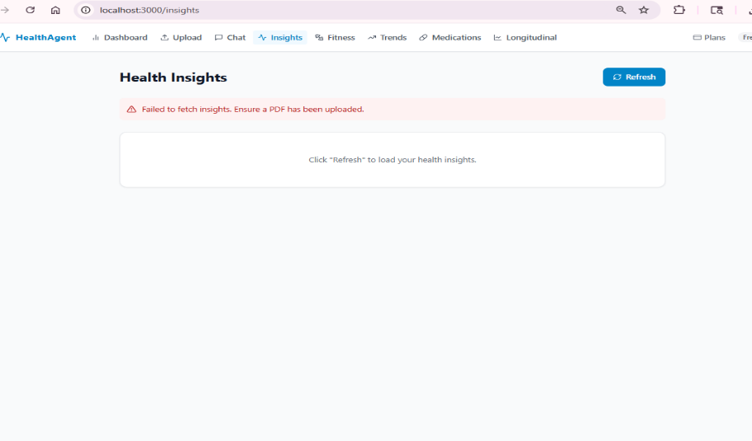

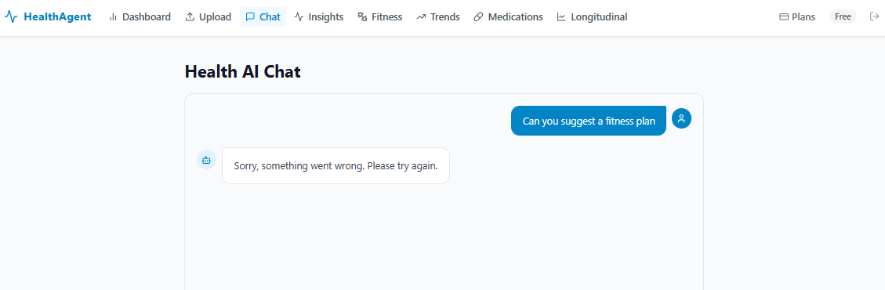
All the agents seems to broken, please fix it, earlier it was working fine.

Bug 2: From Stripe, if we click on back icon, it simply logs out. Rather it should come back to dashboard page.

